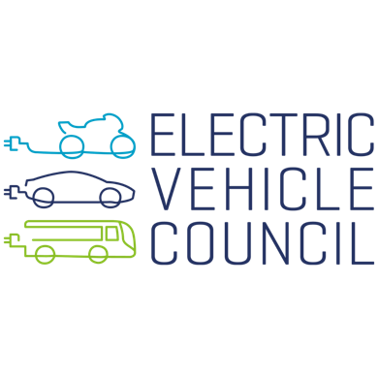
EVC response to the Review of the AER exemptions framework for embedded networks.

November 2023

With reference to:
Review of the AER exemptions framework for embedded networks | Australian Energy Regulator (AER)
Prepared by:
Umair Afzal & Michael Shaughnessy, Electric Vehicle Council

With contribution from:
Ross de Rango

Dear
Mark Feather,
General Manager, Policy
Australian Energy Regulator
GPO Box 3130
Canberra ACT 2601

Introduction

The Electric Vehicle Council (EVC) is the national body representing the electric vehicle industry in Australia. As the market is emerging in Australia, our work is particularly aimed at increasing certainty for investment through policy, knowledge sharing and education.

We represent manufacturers of electric vehicles, energy system actors including generation, transmission, distribution and retail, EV charging and electrical equipment manufacturers, public charging station operators, and many other organisations with a stake in the future involving the electrification of road transport.

The Australian Energy Regulator (AER) is the national regulator for electricity and gas supply in Australia. The AER has responsibility for regulation of energy networks, protecting the interests of consumers through the enforcement of the National Energy Retail Law.
This EVC submission is in response to the AER’s paper linked above (i.e., on the first page).
The EVC has made submissions relating to this area previously which can be viewed as follows:
- EVC response to the AER on: Review of consumer protections for future energy services Options for reform of the National Energy Customer Framework - Electric Vehicle Council
- EVC response to AER retailer authorisation and exemption review issues paper - Electric Vehicle Council
- EVC response to DELWP – Protecting consumers of DER - Electric Vehicle Council

General notes on the paper
The EVC welcomes the AERs review into the exemptions framework for embedded networks and the opportunity to contribute to it. It is imperative that consumers enjoy appropriate protections of their essential services. Consumers are rightly placed at the centre of energy retail and supply, likewise in the energy transition and more specifically the transition of the transport sector.
As the AER notes in its guideline (p52, citation 41), it does not regulate energy used for vehicle charging. For this reason, it is necessary to separate embedded networks dedicated to supplying energy for EV charging from the issues discussed in the paper, which principally relate to embedded networks supplying premises.
The core principles justifying the difference in approach are addressed in the AER’s recent final advice to ministers around consumer protection and has been covered by the EVC in multiple previous submissions – the consumer is not locked in to drawing energy for their vehicle at a particular place or time, and the supply of energy for private transport is not an essential service.
Where supply is not separable, the consumer protections that apply to the premises will now also apply to the EVSE. The EVC notes this is a marked increase in the degree to which supply of private transport energy is protected. Under the situation since Fossil fuel vehicles became mainstream, a consumer unable to pay for fuel has no right to it. In future under this scenario, the ~75% of consumers in Australia with access to off-street parking to charge their EV will be able to put energy in their vehicles and enjoy the same protections to their vehicular energy supply as they do for their electricity supply to the home.
Caution should be exercised such that we do not expand consumer protections needlessly. Over-doing consumer protection in this regard could reasonably be expected to result in reduced competition in the marketplace, and increased costs, which are of course ultimately borne by consumers. In the case of EV, this would constitute the creation of additional barriers to EV uptake, inhibiting our achievement of net-zero goals.

Case Studies
Example 1; Multi-apartment complex embedded network with a shared EV charger for residents use, managed by a CPO. Residents pay the CPO individually for use. There are overheads involved in getting planning, supplying, installing and maintaining the equipment as well as paying for the energy. These costs are passed onto the EV owner plus a margin.
This is closely aligned with AER’s position and logic regarding Public EV charging in the consumer protections framework review – refer to box 5.1. https://www.aer.gov.au/system/files/2023-12/AER%20-%20Review%20of%20consumer%20prote[…]rgy%20services%20-%20Final%20advice%20-%20November%202023.pdf
Example 2a; Multi-apartment complex with a private arrangement between the owners corporation (OC) and the residents. Individual chargers have been installed in allocated parking spaces with the building manager reading a meter for each on a quarterly basis. This structure has potential to be done on a cost-pass-through basis because the OC is buying the energy on a commercial contract, and the metering solution can be relatively cheap with very low overheads. There are still costs of planning, supplying, installing and maintaining the EVSE. A tenant driving 15000 kms per year (vehicle efficiency of 20kWh/100km) at a price of 15c/kWh passed through by the OC will pay about $450 per year.
Example 2b; as above, but with the requirements for a separate on-market meter for each EVSE and an on-market meter for each apartment, as it may not be practical or feasible to run a circuit from each apartment’s main switchboard. At the standard default offer of $1.20 daily supply charge, each resident will pay an extra $438 per year per for the additional meter. If they are able to negotiate off-peak prices and pay on average 20c/kWh for EV charging, they pay $600 in electricity or $1040 overall. Each resident is therefore about $600 worse off per year in ongoing costs, and will need to contribute to the significantly higher capex associated with deployment of on-market metering infrastructure. This example also does not address the expected need for apartment complexes to run active load management of EV charging in their buildings to avoid the need for infrastructure upgrades, which may impact the ability of consumers to effectively utilise on-market retail offers in this setting.
Harms of embedded networks
The EVC acknowledges the distress felt by some residents who have lived under an embedded network (EN) structure that gave them a poor. There are of course the protections afforded through Australian Consumer Law and consumers can always go to their appropriate Ombudsman. However, we also acknowledge that most grievances relate to cost, and come about due to the monopolistic nature of the supply.
EVSE as a load within an embedded network is different, because the inherent monopolistic nature is absent. If prices or conditions for EV charging within the embedded network setting are too high, residents can simply elect to charge their cars elsewhere. This will create significant pressure on the EN provider to provide reasonable and competitive terms.

Benefits of embedded networks
Embedded network architectures, as well as making buildings cheaper to construct, are a key enabler of EVSE installations in apartment complexes, which are important for Australia to meet its electrification and decarbonisation targets. The reason ENs make it easier is that the on-market meter at the dwelling is not necessarily a practicable place to supply the EVSE in the car park from, whereas the common property supply in the building usually will be, and an embedded network architecture is lower cost to deploy.
It is difficult for owners who live in apartments to invest in the transition to EVs, with extra requirements such as planning approvals, OC surveys, meetings and votes to allow installations. Taking away the simplified structure of an embedded network makes it more difficult and more expensive.
As mentioned above, the ability to use an embedded network architecture to support EV charging, where it is wholly separable from the dwelling supply, is likely to put downward pressure on the cost of operating an EV.
EV owners able to charge their EVs at home take pressure off the public charging infrastructure. Unnecessary reliance on the public charging infrastructure will increase the peak demand burden on the electricity network, driving up cost for all consumers.
EVSE installed on an EN is a relatively simple architecture and enables active load management. This is where the EVSE are all part of a system, and the hardware measures the building load with respect to the connection capacity. The software orchestrates the EVSE to use the excess capacity, avoiding the consumers main circuit breaker from tripping or the upstream network fuse from blowing.
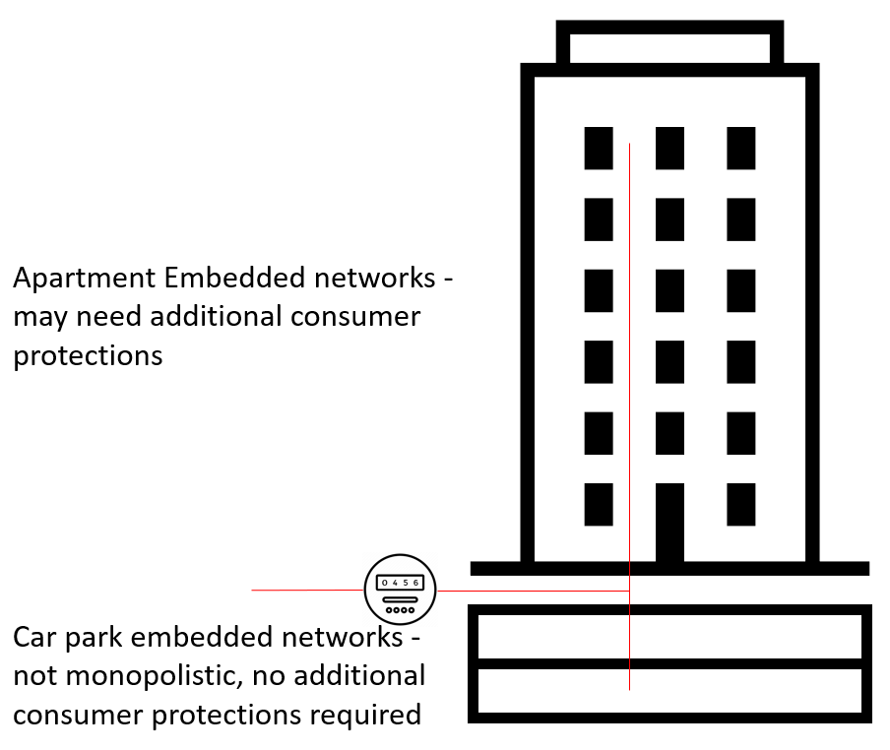

6.3 Interaction with jurisdictional reviews
The Victorian government published a General Exemption Order in 2022 (this was missed in Appendix B of the paper) exempting “A person selling metered or unmetered electricity that is used by the customer to charge an electric vehicle” from retail activity. This effectively provides the position the EVC is advocating that the AER adopt.
7.1.1 Option 1
Dot point 2 states “revise the NR2 registrable network class criteria to capture persons supplying metered or unmetered energy to any residential customers within the limits of a site they own, operate or control.”

This could be reasonably read as including energy:
- supplied by an owners corporation to residents,
- for the purpose of EV charging within the bounds of an apartment complex,
- where the supply to the EVSE is wholly separable from the supply to the dwelling.

This is the opposite of the outcome we’re seeking. Revision to NR2 (if any) should include consideration of the enablement of owner’s corporations and their appointed parties to supply energy for EV charging via embedded network architectures as an exempted activity.
8.1.1 Option 5
Paragraph 5 states “We could require exempt sellers who on-sell energy to residential customers to routinely report performance data based on indicators.”
We note that the Victorian Government’s General Exemption Order (GEO) on this issue sets a data reporting requirement on parties acting under the VD8, in 12.2.d.ii, and that industry feedback to the department is that this measure is likely to prove impractical to effectively enforce. Some manufacturers are not currently collecting some of the data being requested and therefore will be unable to provide it.
Any data reporting requirement of this nature should be co-designed by the regulator and industry, with input from all relevant stakeholders.
8.2 Family violence obligations
For the reasons stated above, energy to vehicles is not monopolistic and not considered essential, therefore energy for EV charging in an EN, where it is wholly separable from energy supplied to the dwelling, should be exempted from having to develop, implement and comply with a family violence policy.

Recommendations
The EVC would recommend that an exemption class should be created related to the supply of electricity for the purpose of charging electric vehicles, in circumstances where the supply of energy to the vehicle is wholly financially separable from the supply of energy for a premises.

The creation of an exemption along these lines would align with the existing state of regulation. This is appropriate for an established service, where no evidence of regulatory failure has been provided, under circumstances where it is reasonable to expect that such failure would be identified e.g., through existing ombudsman schemes.

This is also effectively the approach that the Victorian Essential Services Commission has re-confirmed under the new General Exemption Order under the Electricity Industry Act 2000 (VIC) which came into force on 1 January 2023, confirming that no energy retail licence is required for the sale of electricity used to charge a vehicle.

Conclusion
One of the AER’s strategic objectives is to support the energy transition. In areas that affect the energy transition, particularly nascent industries, regulators should de-regulate where they can and regulate only where they must.
Any extension of regulatory power should be supported by robust evidence and regulatory impact statements, so as not to unnecessarily drive up costs to society through increased regulatory burden and delayed EV uptake.
This is not just about EV uptake or renewable energy uptake - we also want people to take up residence in high density accommodation, as part of solving our current housing crisis.
The EVC is keen to work with the AER on this important reform.
Please contact Umair Afzal at umair@evc.org.au

633e2df594821063f4aea6bf_General Exemption Order 2022.pdf (webflow.com)

